Binomial Probability Distributions
  - In my own words
There are experiments that conform to the four following conditions:
- Said experiment consists of n sub-experiments called trials, where n is fixed beforehand.
- Each trial results in one of two outcomes (dichotomous trials), generically denoted by success (S) or failure (F).
- Trials are independent of each other.
- The probability of success P(S) is constant from trial to trial.
We call such experiments binomial experiments. In most of these binomial experiments, the total number of successes is what we are interested in.
The binomial random variable X associated with a binomial experiment consisting of n trials is defined as the number of successes in the n trials. More formally:
X = the number of successes (S) among the n trials.
For example, if n = 3, then there are eight possible outcomes for the experiment.
{SSS, SSF, SFS, SFF, FSS, FSF, FFS, FFF}. From the definition of X that we gave above,
X(SSF) = 2, X(SFF) = 1, and so on and so forth. It is often denoted in the form of:
X ~ Bin(n, p) to indicate that X is a binomial rv (random value) based on n trials with success probability p.
Notation: Because the pmf (probability mass function) of a binomial rv X depends on the two parameters n and p, we denoted the pmf by b(x; n, p).
Consider a binomial experiment where we set n = 4. Some outcomes of this experiment include {SSSF, SSFF, SFFF, …} and so on.
We can calculate the probability of each of these outcomes via the following method:
In the outcome SSSS, x (number of successes) = 4. The probability of this outcome is p⁴.
In the outcome SSSF, x = 3. The probability of this outcome is p³(1-p). Noting that (1-p) represents the probability of a failure, this is somewhat obvious. We can iterate upon this method to predict the probability of other outcomes. For instance, in the outcome SSFF, we know that x = 2. The probability of this outcome is therefore p²(1 – p)². In general, we can apply the following theorem to find the probability of a binomial experiment.
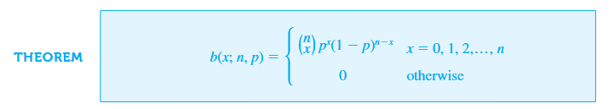
Where ($\begin{matrix}n \\ x\end{matrix}$) (pronounced “n choose x”), represents the number of combinations that can be constructed from n distinct objects (trials in this case).

